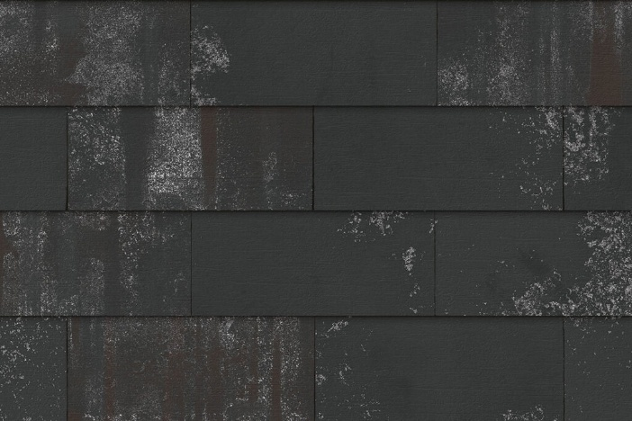

Product Description
Type: Ceramic façade cladding, type: Classic - I-shaped
Textuur: unsanded, low texture
Color: New Black
Black with White-coloured Nuances
Technical Properties
- Dimensions (H x W x D approx.) 225x400x13 mm
- Pieces/m² approx. 12,5
- Dimensional tolerances
Width (in extruded direction): +/- 4 mm
Height (opposite to the extruded direction): +/- 2 mm
Thickness – according to EN ISO10545-2: 13 mm +/- 1 mm
Straightness (in extruded direction) according to EN ISO 10545-2: +/- 1,5 mm
Orthogonality according to – according to EN ISO 10545-2: +/- 2 mm
Flatness: +/- 2 mm
- Water absorption – according to EN ISO 10545-3 3-6%
- Weight: 2,5 kg/pcs +/- 0,5 kg
- Frost resistance – according to EN ISO 10545-12: frost resistant
- Reaction to Fire: Class A1
- Flexural strength - load (225x500 mm) – according to EN ISO 10545-4: > 750 N
- Resistance to thermal shock – according to EN ISO 10545-9: compliant
- Impact resistance – according to EN ISO 10545-5: 0,7-0,9
- Stain resistance – according to EN ISO 10545-14: group 5 (glazed)
- Chemical resistance – according to EN ISO 10545-13: group GA (glazed)
- Thermal expansion – according to EN ISO 10545-8: 5,75 x 10-6 K-1 +/-1

Appearance Characteristics
In a sample of 100 tiles, at least 95 shall be undamaged. Considered as damage: any broken tile, tiles with a broken corner or edge, or cracks in the applied layers, whether visible cracks (< 0.2 mm) or worn-off profiling, provided these are considered disturbing for the visible surface of the tile. The minimum diameter of a defect is 15 mm.
The number of defective tiles must not exceed 5 %. Considered as defects: the presence of inclusions that may cause flaking on the visible surface of the tile upon swelling, or cracks with a width ≥ 0.2 mm on the visible surface.

Transport and storage
Do not stack pallets during transport and storage to avoid breakage.

All data is provided by the manufacturer. Dimensions may vary depending on production. For the most up-to-date version, see www.brickz.world. This document is not binding and supersedes all previous publications. The manufacturer reserves the right to modify the product range and its characteristics. The user must always ensure they have the most recent product description.

